**FUNCTIONAL AND TECHNICAL COMBINED DOCUMENTATION**

**Page (4): Equity Portfolio ---🡪 Return (Front End Url:** http://localhost:8100/page5/Page6)

**Functional Picture:**

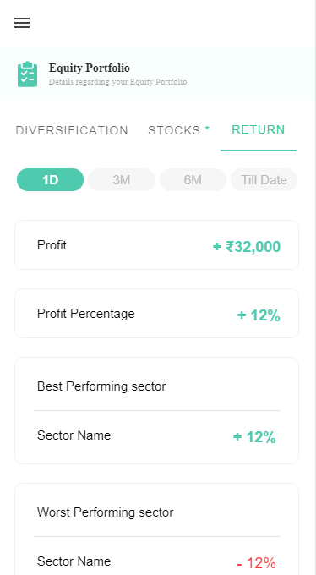

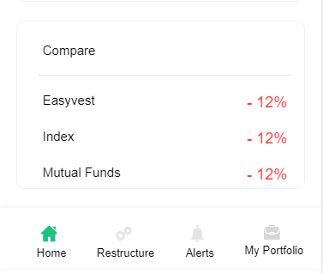

**Technical Explanation (Front End and Back End):**

**In this Page, we are displaying the returns of 1 day, 3 months, 6 months and till date.**

**In Page5.tsx, we are calling following four API’s: Each API is calculating the return of the portfolio with respect to their timeframes. Let’s have a look only on 1 Day return of the return because the remaining 3 months, 6 months and till date follow the same procedure.**

**1) 1 Day:**

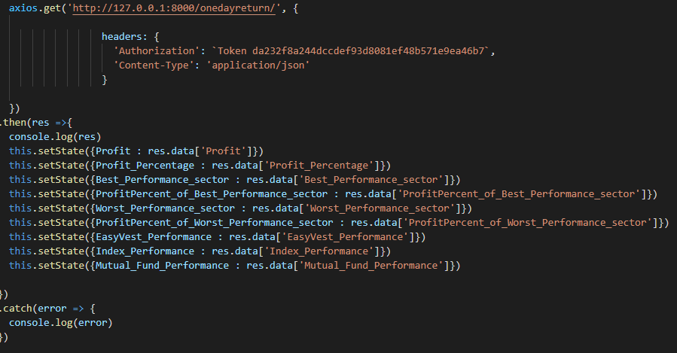

**As you can see in the above front end code snippet, we are calling the url:** [**http://127.0.0.1:8000/onedayreturn/**](http://127.0.0.1:8000/onedayreturn/)**. Now this url is further calling the** OneDayReturnAPI in the Back End code. Kindly see the below code snippet.

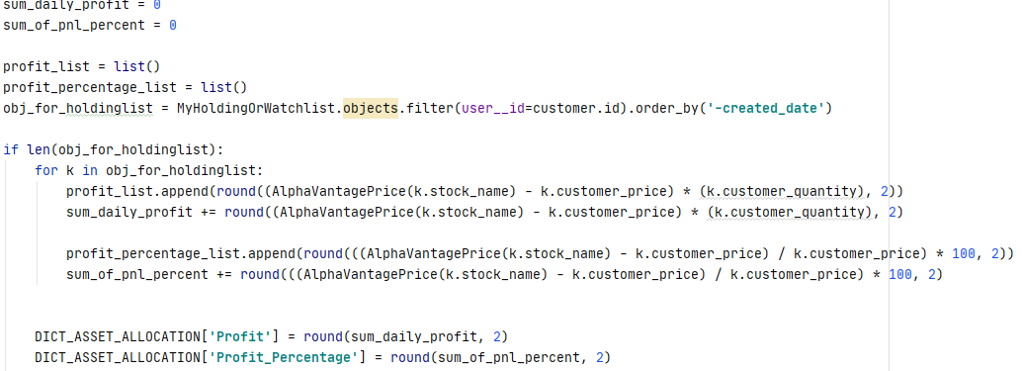

**In the above code, we are calculating the “Profit” and “Profit_Percentage” of the portfolio. We are taking the data from our “MyHoldingOrWatchlist” database model.**

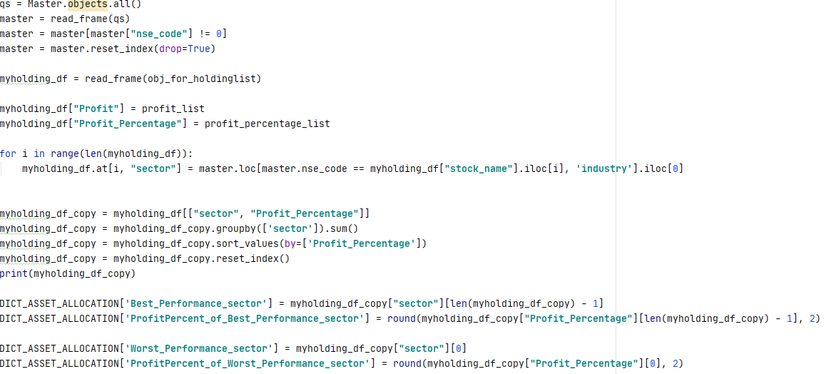

**In the above code, we are calculating for the sector with best performance and worst performance along with their Profits in Percentage.**

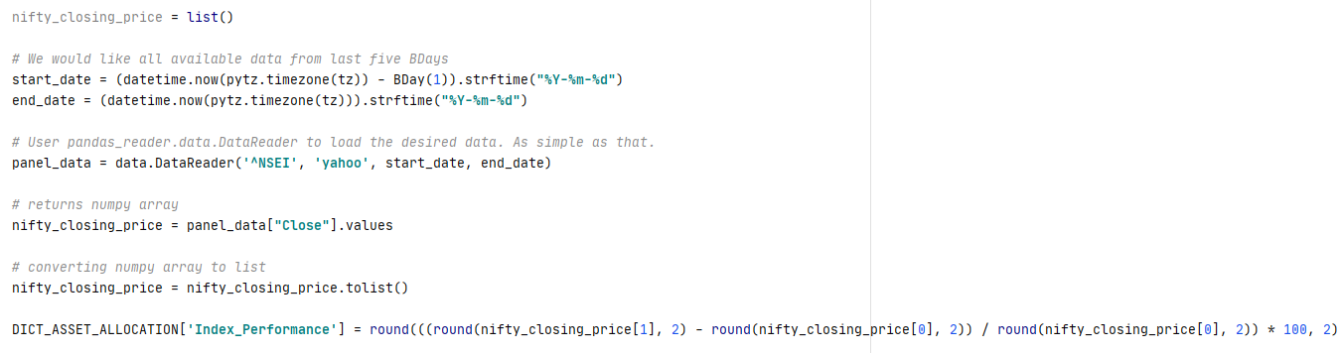

**The above code calculates the Benchmark Index Performance (NIFTY50).**

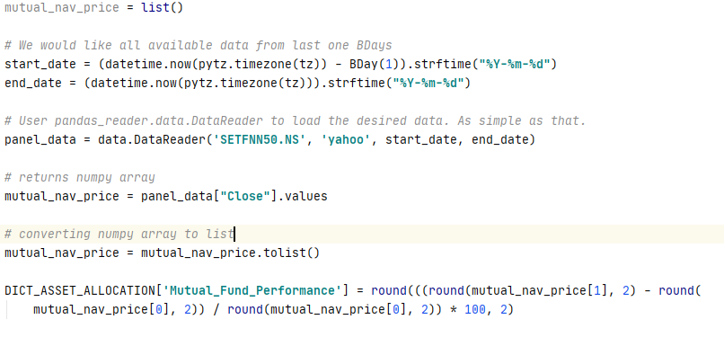

**The above code calculates the performance of the Mutual Fund using its net asset value(NAV) for the given timeframe.**